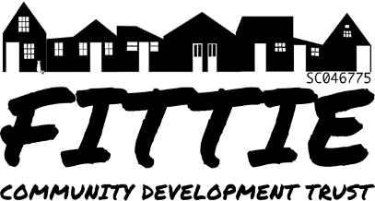

Fittie Community Development Trust
Membership form

I wish to become a Full Member of the Fittie Community Development Trust
*I am aged 16 or over and reside within the the Footdee Conservation Area bounded by the River Dee on the south, the Beach Esplanade to the north, Pocra Quay to the west and the beach to the east.
I wish to become an Associate Member of the Fittie Community Development Trust
*Associate membership is open to people over 16 who are not ordinarily resident within the Footdee Conservation Area, that support the Purposes of the Trust. Associate members are not entitled to vote.
Please note that it is a legal requirement that we seek consent to holding personal data. Therefore, if you do complete your name, address and email below this will confirm that you are happy for the Fittie Community Development Trust to retain these details.

First Names Surname

Address Line 1
Address Line 2
Postcode

Email address

Signature

Date

For completion by the Membership Secretary

Date membership commenced

Date membership ceased

